SOP TO PROCESS NET30 REQUESTS, QUOTES & ORDERS

A. DETAILED WRITTEN SOP (CLEANED & EXPANDED)

1. PURPOSE
This SOP defines the standardized process for:
- Handling Net 30 credit account requests
- Processing orders under approved Net 30 terms
- Ensuring credit verification, accurate PO validation, and correct order conversion
- Minimizing credit risk, processing errors, and order rework

2. SCOPE
This SOP applies to:
- All customers requesting Net 30 terms
- All quotes converted to Net 30 orders
- All Net 30 repayment monitoring and follow-ups
The standard Quote SOP still applies for:
- Quote creation
- Quote follow-up timelines
- Customer communication
This SOP only adds Net 30–specific steps.

3. ROLES & RESPONSIBILITIES

Sales Representative
Responsible for full lifecycle management of the Net 30 request.
Key responsibilities:
- Identify customer eligibility
- Send and collect Net 30 applications
- Coordinate approval with Accounts (Art Goldman – CFO)
- Communicate approval/rejection to customer
- Verify Purchase Orders before order conversion
- Convert quotes into Net 30 orders
- Track delivery and follow up on repayment
- Document all communication and actions

4. PROCESS PHASES

PHASE 1 — CUSTOMER TYPE IDENTIFICATION
The first step is to determine customer type and eligibility.

Scenario 1 — B2B Customer
If the customer is a business customer (B2B):
Action:
- Send Net 30 credit application
- Request completed form
- Begin approval process
Order history is not required for B2B eligibility.

Scenario 2 — B2C Customer With No Order History
If customer is consumer (B2C) and has no order history:
Action:
- Inform customer that at least one prepaid order is required
- Send Net 30 application in parallel
- Net 30 review will occur after prepaid order history exists
Accepted prepaid methods:
- Credit Card
- ACH
- Wire Transfer
- Check

Important Rule
Net 30 customers are NOT eligible for discounts.
Reason:
Net terms already provide extended payment advantages.
Always decline requests such as:
- volume discounts
- coupon codes
- negotiated pricing
Unless manager approval is granted.

PHASE 2 — APPLICATION RECEIPT & SUBMISSION
When the completed Net 30 application is received:

Step 1 — Verify Application
Ensure the application contains:
- Company name
- Contact information
- Billing address
- Trade references
- Required signatures
If information is incomplete:
→ Request corrected application before submitting.

Step 2 — Inform Customer
Send confirmation email.
Standard message:
Net 30 approval typically takes 24–48 business hours.

Step 3 — Submit for Approval
Forward the application to:
Art Goldman (CFO)
artgoldman@dkhardwaresupply.com
Include in the email:
- Completed application
- Quote number (if available)
- Customer details

Best Practice
If possible:
- Collect product information
- Create a quote
- Include quote number in the approval request
Reason:
This allows the CFO to assign an appropriate credit limit.

PHASE 3 — CREDIT DECISION
The Accounts team will either:
- Approve
- Reject

Scenario A — Application Rejected
Actions:
- Inform customer immediately
- Offer prepaid payment options
Accepted payment methods:
- Credit card
- ACH / wire
- check
If the customer has prior prepaid history, advise:
Net 30 eligibility may be reconsidered later.
Always document rejection in notes.

Scenario B — Application Approved
Actions:
- Inform customer of approval
- Request Accounts Payable contact (POC and Email)
- Proceed with quote creation (if not already created)
- Send final quote
- Request Purchase Order (PO)

PHASE 4 — PURCHASE ORDER (PO) VERIFICATION
A Purchase Order must exactly match the quote.
Verify the following:
Field | Requirement
Item Numbers | Must match quote
Quantities | Must match quote
Unit Price | Must match quote
Total Amount | Must match quote
Shipping | Must match quote
Bill To Address | Must match
Ship To Address | Must match
Customer Name | Must match

If PO Does NOT Match Quote
DO NOT convert the order.
Instead:
- Contact customer
- Request corrected PO
Alternative:
Supervisor approval required.

PHASE 5 — ORDER CONVERSION
After PO is verified:
Follow these steps.

Step 1 — Upload PO
Upload the PO file under:
Additional Order Information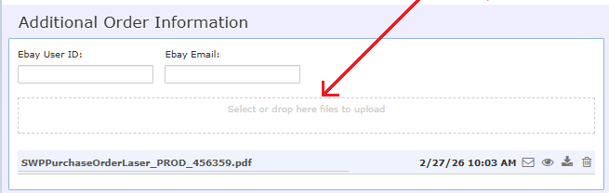

Step 2 — Enter PO Number
Enter PO number in:
Payment Information Section
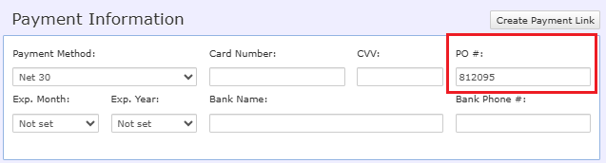

Step 3 — Change Payment Method
Change payment method:
Credit Card → Net 30
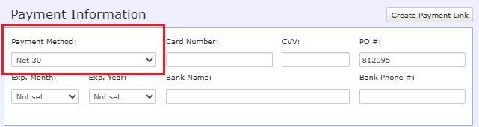

Step 4 — Convert Quote
Select:
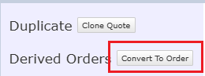
Convert to Order
When prompted:
Select all files to copy:
- PO
- Vendor quote
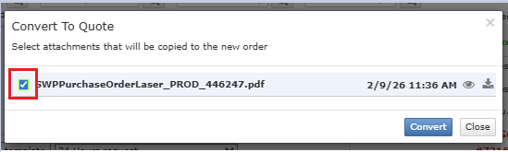
- attachments

Step 5 — System Validation
After conversion verify:
Field | Requirement
Payment Method | Net 30
PO Number | Correct
PO File | Uploaded
Order Items | Match PO

Step 6 — Status Change
Change order status in sequence:
1️⃣ Awaiting Payment
2️⃣ New Orders
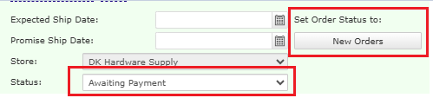

Step 7 — Send Confirmation
Send Order Confirmation Email to the customer.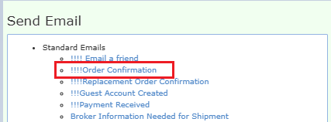

PHASE 6 — ORDER TRACKING
The sales agent must monitor the order until delivery.
Provide customer:
- Shipment date
- Tracking number
- Estimated delivery date (ETA)
Continue monitoring until delivery confirmation.

PHASE 7 — PAYMENT FOLLOW-UP
Net 30 repayment starts 30 days after delivery.
Accepted payment methods:
- ACH
- Wire transfer
- Check
- Credit card payment link

Follow-up Frequency
Minimum:
Two follow-ups per week
Until payment is received.

Contact Priority
- Accounts Payable team
- Buyer
- Company finance contact

Documentation Requirement
Every follow-up must be recorded in notes.
Include:
- Date
- Contact method
- Response
- Expected payment date

5. QUALITY STANDARDS
The following rules must always be followed:
- Net 30 customers cannot receive discounts
- Quote must match PO before order conversion
- All actions must be documented
- Do not paste screenshots into notes
- Only paste clear text information

6. COMPLIANCE
Management may perform:
- Process audits
- Order reviews
- Communication reviews
Non-compliance may result in:
- Coaching
- Retraining
- Process escalation
SOP will be reviewed quarterly.

7

B. DECISION MATRIX
Scenario | Customer Type | Order History | Application Status | Action
B2B customer requests Net 30 | B2B | Any | Not submitted | Send Net 30 application
B2B application received | B2B | Any | Pending | Forward to CFO
B2C with no orders | B2C | None | Request | Require prepaid order
Application incomplete | Any | Any | Incomplete | Request corrected form
Application approved | Any | Any | Approved | Request PO
Application rejected | Any | Any | Rejected | Offer prepaid payment
PO matches quote | Any | Any | Approved | Convert to order
PO mismatch | Any | Any | Approved | Request revised PO
Tax not on PO | Any | Any | Approved | Verify tax exemption
Customer provides shipping account | Any | Any | Approved | Use provided carrier
Payment overdue | Any | Any | Approved | Begin repayment follow-up
Customer requests discount

8.1 Net 30 Application Request
Subject: Net 30 Credit Application – DK Hardware
Hi (Customer Name),
Thank you for your interest in opening a Net 30 account with DK Hardware.
To proceed, please complete the attached Net 30 credit application and return it to me once finished. After receiving the completed application, I will initiate the credit approval process.
The review typically takes 2–3 business days.
Please let me know if you need any assistance completing the form.
Best Regards,
(Rep Name)
8.2 Prepaid Order Required Before Net 30 Eligibility
Subject: Net 30 Eligibility Requirements – DK Hardware
Hi (Customer Name),
Thank you for your interest in setting up Net 30 payment terms with DK Hardware.
At this time, new customers without prior order history are required to place at least one prepaid order before Net 30 terms can be considered.
You may place the initial order using one of the following payment methods:
• Credit Card
• ACH / Wire Transfer
• Check
I have also attached the Net 30 credit application, which you may complete and return after your first order is placed. Once an order history is established, we will submit the application for review.
Please let me know if you need assistance placing the initial order.
Best Regards,
(Rep Name)

8.3 Net 30 Application Received Confirmation
Subject: Net 30 Application Received – Under Review
Hi (Customer Name),
Thank you for submitting your Net 30 credit application.
Our team is currently reviewing the application. The approval process typically takes 2–3 business days.
I will reach out if any additional information is required and will update you as soon as the review is completed.
Best Regards,
(Rep Name)

8.4 Net 30 Approval Notification
Subject: Your Net 30 Account Is Approved
Hi (Customer Name),
Congratulations! Your Net 30 credit account has been approved with DK Hardware.
You may now place orders using Net 30 payment terms, where payment is due 30 days from the invoice date.
To proceed with placing an order, please provide the following details:
Item #:
Quantity:
Ship-to Address:
Billing Address and Email:
Once I receive this information, I will prepare a quote for your review so that you may issue a Purchase Order (PO). Upon receipt of the PO, we will proceed with order processing.
We look forward to working with you.
Best Regards,
(Rep Name)

8.5 Net 30 Application Rejection
Subject: Update on Your Net 30 Application
Hi (Customer Name),
Thank you for applying for Net 30 payment terms with DK Hardware.
After reviewing the application, we regret to inform you that we are unable to approve Net 30 terms at this time.
You are still welcome to place orders using the following prepaid payment options:
• Credit Card
• ACH / Wire Transfer
• Check
Once an order history is established, we will be happy to re-evaluate Net 30 eligibility in the future.
Please let me know if I can assist you with placing an order.
Best Regards,
(Rep Name)

8.6 Net 30 Payment Reminder
Subject: Payment Reminder – Invoice (Invoice #)
Hi (Customer Name),
This is a friendly reminder regarding Invoice (Invoice #) for Order (Order #) delivered on (Delivery Date).
As per the Net 30 payment terms, the payment of $(Amount) is now due.
You may complete the payment using the following methods:
• ACH / Wire Transfer
• Check
• Credit Card (payment link available upon request)
If the payment has already been made, please share the payment confirmation details.
Otherwise, please let me know the expected payment date.
Thank you for your business.
Best Regards,
(Rep Name)

D. QUICK RULE SHEET (CHEAT SHEET)

Customer Eligibility
If | Then
B2B requests Net 30 | Send application
B2C with no order history | Require prepaid order
Application incomplete | Request correction

Credit Decision
If | Then
Application approved | Request PO
Application rejected | Offer prepaid payment

PO Processing
If | Then
PO matches quote | Convert to order
PO does not match | Request revised PO
Shipping account provided | Use customer account

Order Processing
If | Then
Converting quote | Change payment method to Net 30
Order created | Upload PO
Order verified | Send confirmation email

Payment Monitoring
If | Then
Order delivered | Start Net 30 timer
Payment unpaid | Follow up twice weekly
Payment received | Close follow-up

ALWAYS AVOID (COMMON PROCESS FAILURES)
Never:
❌ Convert order without PO verification
❌ Forget to upload PO document
❌ Leave payment method as credit card
❌ Apply discounts to Net 30 orders
❌ Leave notes incomplete
❌ Use screenshots in notes

